**Code Patterns - Pedro Arruda 60663**

Location:

\ganttproject\src\main\java\net\sourceforge\ganttproject\gui\options\model\CustomPropertyDefaultValueAdapter.java

This design pattern is an **adapter**. This adapter facilitates communication between two other classes.

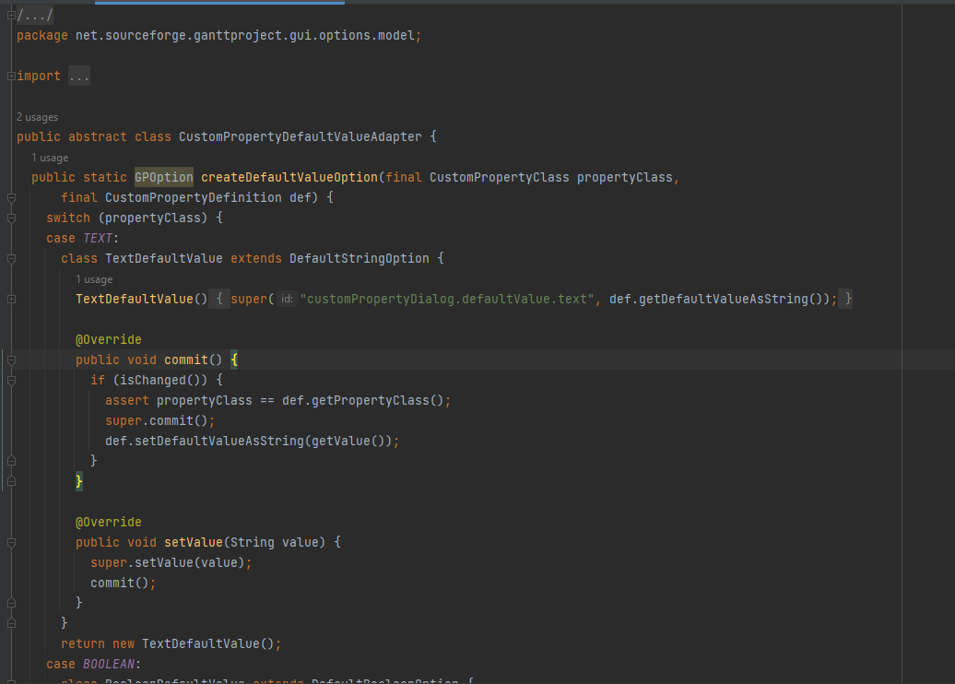

Location:

\ganttproject\src\main\java\net\sourceforge\ganttproject\GanttGraphicArea.java

This design pattern is a **singleton**. With this singleton the class makes sure there can only be one instance of the object myChartComponentImpl.

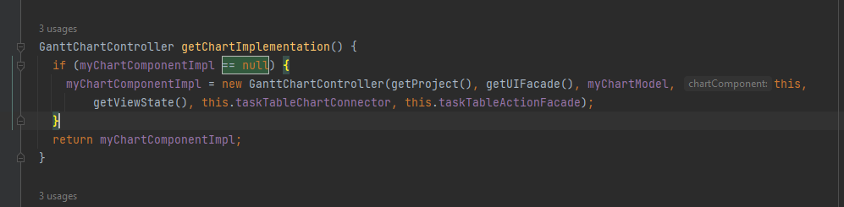

Location:

\ganttproject\src\main\java\net\sourceforge\ganttproject\gui\TreeUiFacade.java

This design pattern is a **facade**. This interface makes it much simpler to use its subsystems and results in less dependency and communication between the subsystems.

